1. **Create an OKE cluster and place both Bastion and OCI Open search within the same OKE node subnet**.
2. Open the ingress and egress ports on node subnet Set up the Open search cluster

Created the open search cluster. Navigate to Databases->Open Search->choose the development

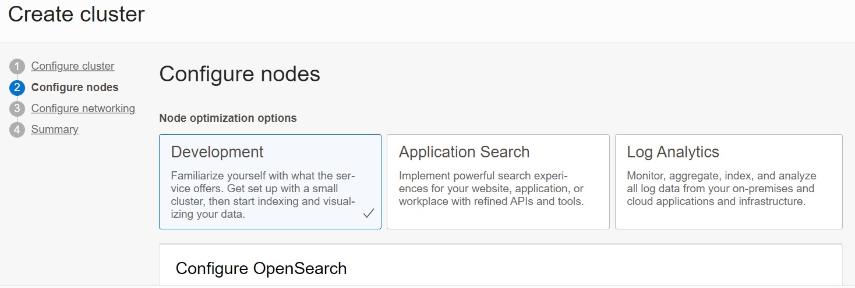

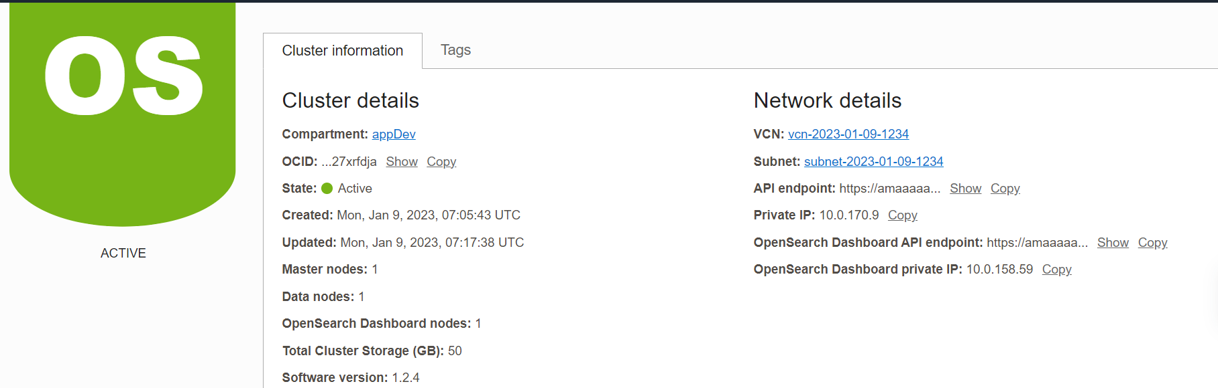

1. Set up the bastion

As the open search endpoints are exposed on private endpoint, we need bastion host to do the port forwarding. Place bastion within the same subnet.

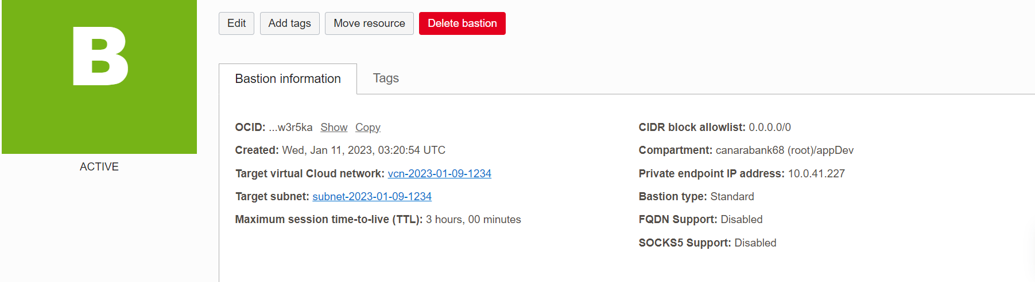

1. Add the security rule for the bastion host

Navigate to subnet -> default security list



10.0.41.227 is the bastion Private IP address.

1. Fetch the details of Open search API End point

Navigate to Databases->Open Search-> Clusters

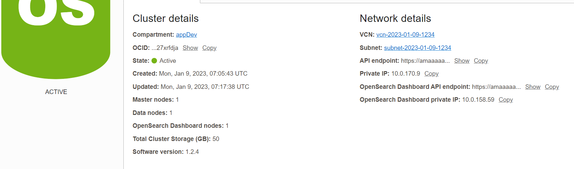

Copy the OpenSearch DashBoard private IP address.

1. Set up the port forwarding session

Copy ssh cmd from bastion port forwarding session

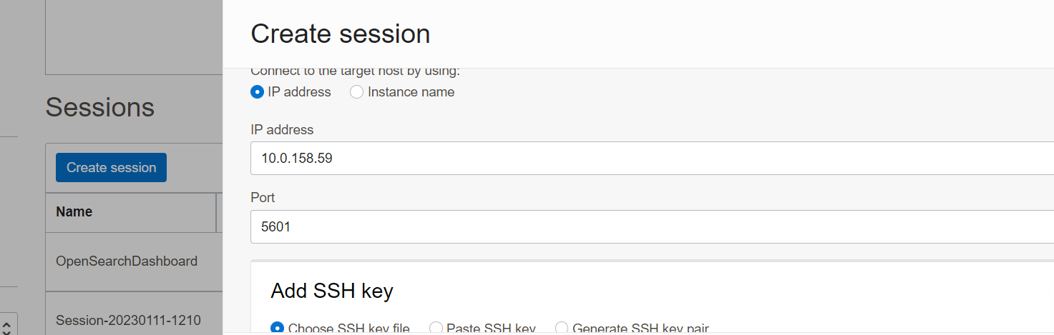

1. Open GitBash/Windows PowerShell as admin cmd

ssh -i C:\\Users\\shilgoel\\Desktop\\open_search_efk_setup\\ssh-key-2023-01-11.key -N -L 5601:10.0.158.59:5601 -p 22 ocid1.bastionsession.oc1.ap-mumbai-1.amaaaaaazuqpw2aadgydx7y5qpjoyuil3cfgf442eq7xn22uycf4dir642yq@host.bastion.ap-mumbai-1.oci.oraclecloud.com

1. Open the browser

<https://localhost:5601/>

1. Installing fluentBit, and fluentd as per the GIT link :- <https://github.com/shilpigoelVB/fluentd_fluentbit>
2. The pods should be visible as below:-

system fluentbit-fluent-bit-69nxn 1/1 Running 0 13h

system fluentd-565fc9fcf5-cc5vk 1/1 Running 0 13h

1. Under the OCI Open search the index pattern will be displayed as below:-

